Lesson 3:

John the Baptizer
SCRIPTURE REFERENCE:
Luke 1:5-25, 57-80; luke 3:1-20; Mark 1:1-8, Matthew 3:1-12
MEMORY WORK:
Bible Skills 1-6
John 3:16
The 12 Apostles
PERSONAL APPLICATION:
With God’s help, I can grow in the same ways that Jesus did
LESSON STARTS HERE
INTRODUCTION:
Jesus spent His growing up years preparing for what God sent Him to Earth to do. There was a man who was sent to prepare the people for what Jesus was going to teach them. A priest named Zacharias and his wife Elizabeth were an older couple who had faithfully served God all their lives. But they were sad because they had no children. They prayed many years for a son.
POINTS TO EMPHASIZE:
- As a priest, Zacharias was expected to serve at the Temple in Jerusalem (possibly twice a year, one week at a time). A priest was allowed to offer incense in the Temple only once in his life, and Luke chapter one tells us about Zacharias’ opportunity to do that. He must have been very excited and nervous to be in charge of this important part of the Temple worship.
- The incense had to be carried into the Holy Place twice a day (“the hour of incense”—Luke 1:10), at 9:00 in the morning and 3:30 in the afternoon, by one priest. When Zacharias took the incense into the Holy Place, an angel appeared and spoke to him. The angel Gabriel told him that Elizabeth and he would have a son, even though they were old. The angel also told Zacharias that their son would be a special teacher who would help people prepare themselves for the coming Messiah. The angel said the baby boy’s name would be John, which means “Jehovah has been gracious.” [Note prophecies in Malachi 3:1, 4:5-6.] Zacharias was afraid and asked for proof (a sign). “How can this be since my wife and I are old?” Because he questioned this message from God and showed a lack of faith, the angel told Zacharias that he would not be able to say another word until after his son was born. Meanwhile many people were outside waiting for him and couldn’t understand why he was inside so long. They were all very surprised when he came out unable to speak.
- Zacharias and Elizabeth returned to their home in the hill country of Judea and waited for their son to be born as the angel promised. On the day John was born, their neighbors and friends gathered to celebrate with them. When he was 8 days old (according to the Old Law, the time of circumcision), they were all eager to see what name had been chosen for the baby. They assumed he would be named after his father. But Zacharias used a tablet (possibly wood covered with wax) to write them a note saying, “His name is John.” At that very moment, Zacharias was able to talk again.
- His first words were a long praise to God and a prophecy about the great teacher his son John would become. Neighbors and friends were amazed and wondered, “What kind of child will this be?” Zacharias and Elizabeth were prepared to be godly parents. They were ready and willing to follow God’s instructions about raising their son.
- John “continued to grow, and to become strong in spirit.” When he was grown, he lived in deserted areas away from towns and people. He wore a leather belt and very rough clothes made of camel’s hair. He ate honey and locusts. He looked different, he lived differently, and he preached differently than other men the people had heard.
- John started preaching to the Jews near the Jordan River when he was about 30 years old, as the angel had said he would (Luke 1:16-17), telling them to repent of their sins and be baptized. John was prepared to do anything that God expected of him, and he wanted the Jews to be prepared to do what God expected of them when the Messiah (Jesus) came.
- The Boy Scout motto is “Be Prepared!” and ours should be too. We should always be ready to do what God asks us to do, whether it is helping others or obeying certain commands, like how to become a Christian or how to worship.
Repent: To change your mind, or the way you think about the things God says are wrong and choose not to do those things anymore. Repentance is turning around your life and going in another direction.
Baptism: To be completely immersed or put under water.
NOTE:
John’s baptism:
- was for the remission of sins committed under the Old Law. Promoted change in thinking (i.e., repentance—Acts 19:4), and, therefore, a change in lifestyle. Those baptized confessed their sins (Matthew 3:6).
- prepared believers to obey the coming Messiah (Acts 19:4).
- was not to become a Christian, since it preceded the baptism of the Christian era. See Matthew 3:1-11; Mark 1:4-5; Luke 3:1-7,16; John 1:25-33; Acts 13:24; 18:26-19:7
John was called “the Baptist” or “the Baptizer” because of what he did, just like Joseph the carpenter or Simon the tanner. He did not start a church of his own, nor should we be part of a religious group identified by his name.

“Filled with the Spirit”: both Zacharias and John were said to be “filled with the Spirit,” i.e., to be guided by (or controlled by) the Spirit to do and say things that God wanted done and said.
RECOMMENDED ADDITIONAL VISUALS (note disclaimers):

Betty Lukens’ felt pieces
- ABeka Flash-a-Card Series (DISCLAIMER: use the cards, not the lesson book;)
- Free Bible Images – Saved on flash drive. Can be presented on classroom tv. Script included in lesson file.
SONGS AND FINGERPLAYS:

SUNDAY
LEARNING CENTERS AND ACTIVITIES:
Focus activities on the first part of the lesson – John’s birth
- Use small dry erase boards and markers to let students write messages like John’s father. This age level may not read well so they will probably have to use pictures or beginning letters. Or the teacher can try to get the students to figure out a message by only drawing and not talking, similar to pictionary. Discuss how difficult it would have been for Zachariah when he could not talk.

WEDNESDAY NIGHT
POINTS TO EMPHASIZE:
- Review Sunday’s lesson. (See Review Questions for example questions.)
LEARNING CENTERS AND ACTIVITIES:
Focus activities on the second part of the lesson – John’s adult ministry
- Clothespin locust – Make a locust like John would have eaten. Supplies needed are clothespins, green marker, green pipe cleaners (pre-cut to appropriate lengths), and tape. Googly eyes and glue optional.
Step 1: Place a piece of tape, sticky side up on table. Help students press the leg sticks across the tape.
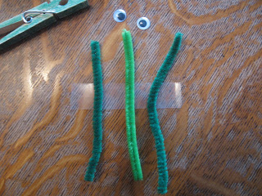
Step 2: Color the clothespin green. Put the clothespin on top of the pipe cleaners. Fold the tape around on the sides of the clothespin.
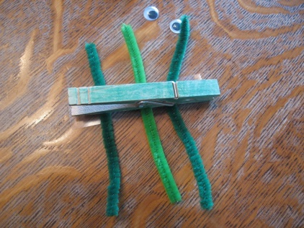
Step 3:Slip the shorter antennae piece through the hole in the clothespin. Bend the legs to make the locust stand.
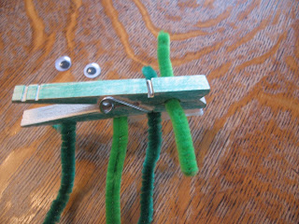

Step 4: Twist the antenna around the top and add wiggly eyes or draw on eyes
. 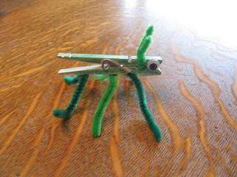

Review Questions
- What was John the Baptizer’s dad’s name?
  - Zacharias or Zachariah
- What did John’s dad do for a living?
  - He was a priest
- What was John’s mother’s name?
  - Elizabeth
- How did Zachariah know that he would have a son?
  - The angel told him
- After Zachariah’s encounter with the angel, what happened to him as a sign that this was true?
  - He was not able to speak until eight days after John was born
- How many times in their life could they offer up incense?
  - Once
- What does the word “Messiah” mean?
  - Anointed one; also means the same as Christ
- Where was Zacharias’ and Elizabeth’s home?
  - Judea
- What did Zacharias use to tell everyone what the name of his Son would be?
  - Tablet
- What is incense?
  - Perfumes and spices that smell sweet when burned
- After Zacharias told the name of his Son, what was he able to do?
  - Talk
- When John was an adult, where did he live?
  - Wilderness
- What did John wear as clothes?
  - Camel’s hair
- What did John eat?
  - Honey and locust
- What was John’s mission?
  - He came to prepare the way for the coming Messiah
- What did John do to prepare the way for the Messiah?
  - He preached
- What did John preach?
  - Repentance and baptism
- Where did John teach and preach?
  - Jordan River
- How old was John when he started preaching?
  - 30
- What does repent mean?
  - To change your mind about doing things God says are wrong and choose to do right
- What does baptism mean?
  - To be completely immersed
Additional Notes / Activities Performed & Curriculum Feed Back

__________________________________________________________________________________________________________________________________________________________________________________________________________________________________________________________________________________________________________________________________________________________________________________________________________________________________________________________________________________________________________________________________________________________________________________________________________________________________________________________________________________________________________________________________________________________________________________________________________________________________________________________________________________________________________________

