Lesson 12:

Rehoboam Follows Poor Advice
SCRIPTURE REFERENCE:
I Kings 12
MEMORY WORK:
Psalms 23:1 The Lord is my shepherd; I shall not want.
PERSONAL APPLICATION:
I must never think that I “know it all”; I must be willing to listen to the advice of others who want to help me obey God and go to heaven.
LESSON STARTS HERE
INTRODUCTION:
Who was the first King of Israel? Who was king after David? Did he always make good choices? What were some bad choices Solomon made? After Solomon died, his son Rehoboam became king. But Rehoboam did not learn from his father’s mistakes.
POINTS TO EMPHASIZE:
- Rehoboam was the son of Solomon and Naamah, an Ammonitess (1 Kings 14:21)—that means that she was a woman from the kingdom of Ammon. [She was one of many idol-worshipping women that Solomon married (1 Kings 11:1).] First Kings 14:21 says that Rehoboam was 41 years old when he became King of Israel, and he was king for 17 years. Solomon had left behind great wealth, but he had also required a heavy tax burden to support his massive building projects, his army, and his enormous family.
NOTE: Different dates for Rehoboam’s reign have been estimated, but the most likely is 931-913 B.C. Note also that some have argued that a scribal error was introduced in 1 Kings 14:21 in the age of Rehoboam. They argue that Rehoboam was much younger than 41 (possibly 21 or 16), based on 2 Chronicles 10:8, 13:7, and 1 Kings 12:10.
- The Israelites were very tired of high taxes that supported Solomon’s extravagant lifestyle. They were afraid that Rehoboam would carry on his father’s policies. The capital city was Jerusalem, but Rehoboam decided to go to an ancient city in the northern section, Shechem, to meet with the people and to try to gain their support. Instead, he was met with demands for lower taxes and questions from the people about what he planned to do.

- Rehoboam asked for advice and then chose to follow the advice of the younger men instead of the older, wiser men. He combined his poor judgment and/or arrogance with the poor advice of his peers. The result was that the 10 northern tribes revolted and became a separate nation—known as the northern tribes or Israel. Only the two southern tribes of Benjamin and Judah (thereafter known only as Judah, or the southern tribes) stayed under Rehoboam’s control. The other 10 tribes decided to follow Jeroboam. This was the beginning of the divided kingdom (see map in recommended visuals).

NOTE: Shechem was an important city in the hill country of Ephraim between Mt. Ebal (the mount of blessing) and Mt. Gerizim (the mount of cursing). Jacob had lived in Shechem for a while and dug the famous well where Jesus talked to the Samaritan woman in John 4; it was then called Sychar. Shechem was one of the Cities of Refuge provided under the Law of Moses. During the time of Joshua and the judges, it was an important meeting place of the northern tribes (Joshua 24:1). Later Shechem became a major city of the Samaritans. Today it is a large city called Nablus, inhabited mostly by Muslims..
NOTE: If Rehoboam was 40-41, his peers would not have been “young” by our standards (cf. 1 Kings 12:10; 2 Chronicles 10:8). Also, remember that the 12 tribes at this point were 11 sons of Jacob, with both of Joseph’s sons getting an inheritance, making 12 land allotments. The Levites were given cities throughout the kingdom rather than specific areas of land.
- Immediately, Rehoboam tried to make the southern kingdom (tribes of Judah and Benjamin) stronger. He fortified Bethlehem, Hebron, and other cities. Priests and Levites who did not want to serve under Jeroboam went to the south, to Rehoboam. They helped provide some leadership for the first three years of Rehoboam’s reign—until he started promoting idol worship (2 Chronicles 11:17). Rehoboam continued to live in luxury, as his father had. He had a large family (2 Chronicles 11:18-23) and spent lots of money on elaborate places for idol worship. He did not bring his people back to God. When his kingdom was well established and strong, he “forsook the law of the Lord” (2 Chronicles 12:1).
NOTE: God sent Shishak, King of Egypt, to Jerusalem with a massive army to take tribute. Shishak was the son of an Assyrian king. His wife (Tahpenes) is mentioned in 1 Kings 11:19. One of his wife’s sisters became the wife of Jeroboam. Shishak invaded the Southern Kingdom with twice the number of chariots that Pharoah used in the time of Moses (Exodus 14:7), five times as many horsemen as Solomon had, and 12 times as many Philistines as came against Israel in 1 Samuel 13:5. His infantry was “without number.”
- We can learn from Rehoboam how important it is to listen respectfully to those who are older, like our parents, grandparents, teachers, older people in our congregation, etc. They have lived longer, usually know more, and are usually wiser. Older Christians who love God want to help us get to heaven. They can be a big help to us as we grow up. Read together Leviticus 19:32; Proverbs 16:31; 1 Peter 5:5; Proverbs 1:5; 11:14; 19:20.

THE DIVIDED KINGDOM

 | Israel | Judah
Number of Tribes | 10 | 2
First King | Jeroboam | Rehoboam
Number of Kings | 19 | 19+1 queen (Athaliah)
Number of Dynasties | 9 | 1
Kind of Kings | All bad; some worse | Some good; most bad
Capital | Samaria | Jerusalem
Fate of Kingdoms | Conquered and deported by Assyria: 722 B.C. (no return) | Conquered and deported to Babylon: 586 B.C.  (exiles returned)

RECOMMENDED ADDITIONAL VISUALS (note disclaimers):

Betty Lukens’ felt pieces
- Free Bible Images – Saved on flash drive. Can be presented on classroom tv. Script included in lesson file. The file is labeled “11-12-13” because it has multiple lessons on it. Begin this lesson on slide 6. Information is given about Jeroboam but focus most of your attention on Rehoboam and his weaknesses. Save the discussion of Jeroboam for next week’s lesson.
- Army men, Little People –look for Prince or king looking characters, construction paper – see Sunday Activites
SONGS AND FINGERPLAYS:

SUNDAY
LEARNING CENTERS AND ACTIVITIES:
- Act out the scenario with army men, and little people toys. Children this young probably do not understand reading a map yet. Use a piece of construction paper to represent the nation of Israel. When the nation divides, tear the piece of paper in two and move the toys into the two separate pieces of paper. Now there are two countries – Israel (north) and Judah (South)
- Divided Crown Coloring Activity – Color the provided divded kingdom coloring sheet. Make a crown out of yellow construction paper and cut down the middle. Fasten with a brad at the bottom. Keep a copy for reference in the lesson file.
- Look at pictures in the pictorial directory of some of the older members of the congregation. Call them by name. Talk about ways that we learn about how to be good Christians from them.

WEDNESDAY NIGHT
POINTS TO EMPHASIZE:
- Review Sunday’s lesson. (See Review Questions for example questions.)
- Emphasize the importance of praying for our leaders—at home, in the church, in our schools, in our city, in our state, and in our country (1 Timothy 2:1-2).
- Children are often kind of scared of the elderly, because they look and act so different than them. Talk about why they’re different to help the children understand them and respect them more. Perhaps discuss how they’ve changed since they were first born. Their minds—who they are— hasn’t really changed all that much, though their body has. Same thing with old folks. Many times their mind hasn’t changed, but their body has. They may be more quiet because they can’t hear as well, or because they’ve learned the wisdom of holding their tongue, or because they’re in pain; they may be grumpy because of their pains, too, just like we all are, except they probably have more pain than we do. But notice, they’re still just like you and me. They like attention, friendship, to feel needed, to feel loved, and they especially love to see children.
LEARNING CENTERS AND ACTIVITIES:
- Talk about the importance of making good choices. Give the children different scenarios where they could make a good choice or a bad one (e.g., whether or not to share something, whether or not to obey Mom or Dad, whether or not to take something that doesn’t belong to them, etc.).
- Choose Good Advice Activity (provided in lesson file) On magnetic dry erase board draw an ear on one side and an ear crossed out on the other side. Sort pictures into either “people we should take advice from” (the ear) or “people we should not take advice from” (the crossed out ear). If board is not available, pictures can be sorted at the table.

Review Questions

- Who were Rehoboam’s parents?
  - Solomon and Naamah, an Ammonitess

- How old was Rehoboam when he became King of Israel?
  - 41 years old

- How many years did Rehoboam reign as King of Israel?
  - 17 years

- With what had Solomon left the Israelites that made them unhappy?
  - A high tax to support Solomon’s extravagant lifestyle

- Instead of Jerusalem, where did Rehoboam decide to go to meet the people?
  - Shechem, an ancient city in the northern section

- How did the people react to Rehoboam?
  - They had demands for lower taxes, and they questioned what he planned to do as king.

- When Rehoboam asked the older men and the younger men for advice, whose advice did he follow?
  - The younger men

- Did the young men give Rehoboam good advice?
  - No

- What was the result of Rehoboam’s bad decision?
  - The 10 northern tribes revolted and became a separate nation, known as the northern tribes of Israel.

- Which two tribes stayed with Rehoboam?
  - Benjamin and Judah

- How would Rehoboam’s tribes be known?
  - As Judah, or the southern tribes

- Who did the other 10 tribes decide to follow?
  - Jeroboam

- Who helped provide leadership in the southern tribes during the first three years of Rehoboam’s reign? (
  - The Priests and Levites who did not want to serve under Jeroboam

- What bad thing did Rehoboam eventually start doing in his kingdom?
  - Idol worship

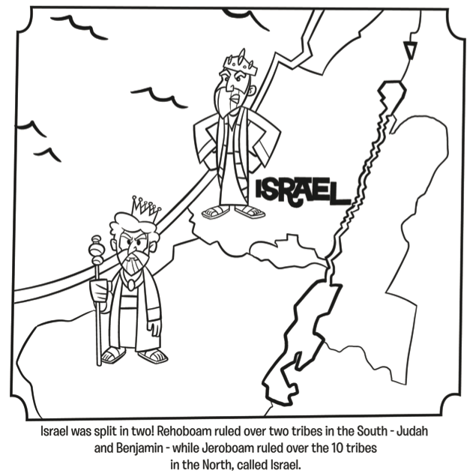

Additional Notes / Activities Performed & Curriculum Feed Back

__________________________________________________________________________________________________________________________________________________________________________________________________________________________________________________________________________________________________________________________________________________________________________________________________________________________________________________________________________________________________________________________________________________________________________________________________________________________________________________________________________________________________________________________________________________________________________________________________________________________________________________________________________________________________________________

