Lesson 13:

The Ten Commandments
SCRIPTURE REFERENCE:
Exodus 19, 20, 24
MEMORY WORK:
Insert your own
PERSONAL APPLICATION:
God gives us rules (laws, commandments) in the Bible that He expects us to obey. He knows that we need His rules to help us get along with others and to be happy.
LESSON STARTS HERE
INTRODUCTION:
What do you think would happen if we didn’t have rules? It would be terrible! If we had no rules at home, everyone in the family would be ugly to each other, maybe even hurt each other. If there were no rules about driving, there would be lots of wrecks, and many people would be hurt. If there were no rules at school, you would not have a safe place to learn. When God guided the Israelites out of Egypt, He knew that they would need rules to help them get along and to stay safe. Today we’re going to talk about how God gave His rules to the Israelites.
POINTS TO EMPHASIZE:
- Briefly remind the children how God delivered the Israelites (i.e., Hebrews or Jews) from being slaves in Egypt, and how He guided them through the desert, providing everything they needed.
- The Bible tells us that there were 600,000 Israelite men, not counting women and children. (It has been estimated that there were two or three million Israelites all together, traveling from place to place in the wilderness on their way to the Promised Land of Canaan.) So many people traveling together and living close to one another in tents! God knew that the people had to have some rules to help them get along with each other. They also needed to be reminded how to worship God and show Him respect. (Remember that they had been in Egypt with no apparent communication from God for several hundred years.)
- After three months of traveling, the people came to Mount Sinai (also called Mount Horeb and “the mountain of God”). This was the same mountain where God had spoken to Moses through the burning bush and told him to go to Egypt to lead the Israelites out of slavery. This time, God called Moses up on the mountain. God told him that this large group of people would be a great nation (just as He had promised Abraham hundreds of years earlier)—but only if they obeyed Him! He told Moses to bring the people around the foot of the mountain in three days, with their bodies and clothes washed and their minds ready to listen to His words.
- Moses went down from the mountain to tell the people what God had said. They promised to obey—to do everything God commanded. On the morning of the third day, there was a great deal of thunder and lightening around Mount Sinai, and a thick cloud came down on the mountain. The ground shook! There was fire on the mountain! A loud trumpet sounded! And God Himself spoke to the people from a great cloud (Deuteronomy 4:11-13 and 5:22), telling them ten special laws that would help the people know how to get along, to know how to be happy, and to know how to be the God-fearing nation that He wanted them to be. These were the Ten Commandments. But the people were so frightened that they did not want to go any closer to the mountain or directly hear the voice of God (Deuteronomy 5:23ff.; Exodus 20:18ff.). So Moses went to hear God while the people stood far away.
- God gave Moses other commands which he told the Israelites. Exodus 24:3 tells us that the Israelites said they would obey God’s commandments. Then Moses went up on Mount Sinai again, this time for 40 days and 40 nights. God gave Moses the Ten Commandments on two tablets of stone that He had written down for the Israelites Himself, and gave them to Moses, along with many other commands.
- The first four of the Ten Commandments told the Israelites how they should show respect and love for God. They were not to make idols to worship like the Egyptians or other people did. God also told them not to worship anything that He had made—not the Sun or Moon or stars or anything else, like other people were doing. (Remember that the Israelites had been in Egypt for many years, surrounded by idols and all kinds of idol worship.)
TEACHERS’ NOTE: Explain that to be “profane” is to be disrespectful about something that should be treated respectfully or taken seriously. Esau was described as “profane” in Hebrews 12:16, because he sold his birthright—which should have been taken seriously— for a simple bowl of stew. We are to be respectful of things that should be taken seriously (1 Timothy 1:9), or we will be guilty of being profane, like Esau. This means that we should not say the Lord’s name without thinking about Him, and we should not say other words that represent things that should be taken seriously as well (like saying “hell” when we are not talking seriously about this place or words that tell others to go there or bad words that represent sinful things that should be taken seriously).
TEACHERS’ NOTE: You need to explain to preschoolers that an idol can be a man-made object or something in nature that people choose to worship.
- The Israelites, as God’s chosen people, were to be very respectful and reverent when using God’s name. We should be just as reverent and respectful about God’s name and not use it in slang. A lot of people today use His name in ways that make Him very unhappy, such as, “Good Lord” or “Oh, my G—,” etc. God’s name is holy, and we should only say His name when we are thinking about Him.
- The Israelites were commanded to set aside one day every week to rest, to worship, and to remember what great things God had done, and continued to do, for them. The 7th day of the week, also called the Sabbath (Saturday), was set aside for the Israelites as their day of worship to God. There is no Sabbath command under Christianity, but the first day of the week, Sunday, is a special day for Christians. We gather to worship and take the Lord’s Supper on that day (Acts 20:7), because that is the day Jesus was raised from the dead and the church was established.
- The last six of the Ten Commandments told the Israelites how they were to treat each other. They were to honor and respect their parents; God knew that if they didn’t show honor and respect to people they could see, they would never show honor and respect to Him Whom they could not see.
- God told them not to murder, not to steal from one another, and not to lie about each other. He told them to love their own husbands and wives—not someone else’s. He told them to be happy with what they had and not covet. (Discuss each of these as much as is appropriate for your age group.)
Covet: to be jealous of what others have and to want what they have.

RECOMMENDED READING FOR TEACHERS: See the article titled “Taking the Lord’s Name in Vain” by Kyle Butt on the Apologetics Press Web site for a study on that subject.
RECOMMENDED ADDITIONAL VISUALS (note disclaimers):

Betty Lukens’ felt pieces
- ABeka Flash-a-Card Series (DISCLAIMER: use the cards, not the lesson book;)
- Free Bible Images – Saved on flash drive. Can be presented on classroom tv. Script included in lesson file. These Visuals are labeled “13” in the Visuals file on the flash drive.

SONGS AND FINGERPLAYS:

“THE TEN COMMANDMENTS” (Click to Hear)
Author: Unknown* (Tune: “Ten Little Indians”)
You shall have no gods before Me. (3X) This is commandment one.

You shall not worship idols. (3X) This is commandment two.

Do not take God’s name in vain. (3X) This is commandment three.

Remember the Sabbath to keep it holy. (3X) This is commandment four.

Honor your father and mother. (3X)
This is commandment five.

God said, “You shall not kill.” (3X) This is commandment six.

You shall not commit adultery. (3X) This is commandment seven.

God said you shall not steal. (3X) This is commandment eight.

Never, never tell a lie. (3X) This is commandment nine.

God said, “You shall not covet.” (3X) This is commandment ten

“The Ten Commandment Finger Memory”

From Blog: Ihavenogreaterjoy.wordpress.com

Note: This is a memorization aid using the fingers. It could be used in conjunction with the 10 commandment song or simply speak each commandment

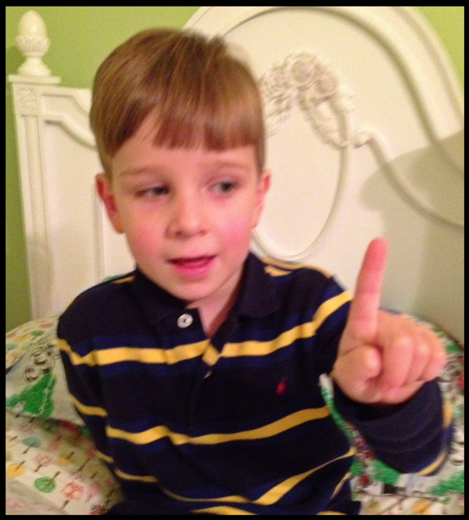
1. Thou shalt have no other gods before me. (Hold up one finger for commandment 1, only 1 God, and point up to God. You can also move your finger from side to side and shake your head for “no” other gods.)
……….
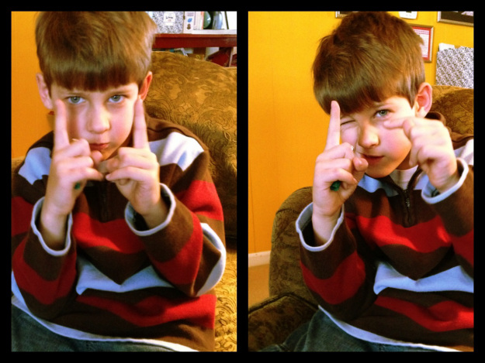
2. Thou shalt not make unto thee any graven image. (Hold up a finger on each hand for 2nd commandment. One finger bows down to other as an idol.)
……….
3. Thou shalt not take the name of the Lord thy God in vain. (Hold up three fingers for #3 and then put over mouth to not speak!)
……….
4. Remember the Sabbath day to keep it holy. (Hold up four fingers for #4 and then move to side of face and tilt head as if resting.)
……….
5. Honor thy father and thy mother. (Hold up five fingers for 5th commandment. Make a spanking motion with your hand! )
……….
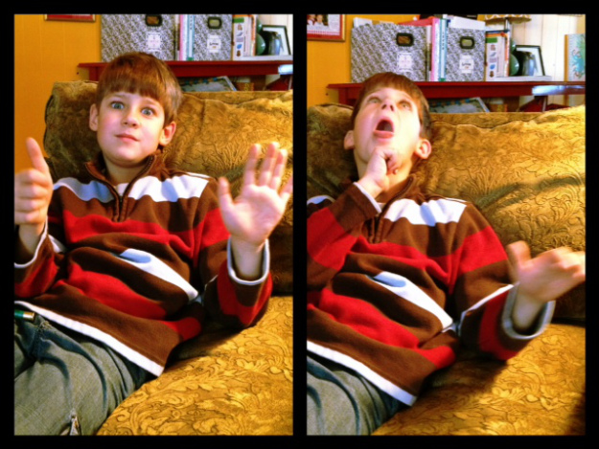
6. Thou shalt not kill. (Hold up six fingers, and then make a stabbing motion with one finger.)
……….
7. Thou shalt not commit adultery. (Seven fingers up. Cross the two fingers on hand back and forth to show mom and dad / husband and wife together forever.)
……..
8. Thou shalt not steal. (Eight fingers up for #8 with one hand grabbing and stealing the 3 fingers on the other hand.)
……….
9. Thou shalt not bear false witness against thy neighbor. (Nine fingers up then over mouth again like #3. This time the hand with five fingers is followed by the hand with four fingers.)
………

.
10.
Hold up ten fingers. Thou shalt not…
Make a grabbing motion as if taking something from another.
…covet!

SUNDAY
LEARNING CENTERS AND ACTIVITIES:

Review Commandments using hand motions

Make the tablets – Using Crayola Air Dry Clay and Tombstone cookie cutters(Available near Halloween) or rectangle cookie cutters let students roll out clay and cut two tablet shapes. With a tooth pick students can write the numbers 1-10 on the tablets. These tablets will need to dry overnight so don’t send them home this Sunday. You can leave instructions for the Wednesday teacher to send them home or save them to go in an ark of the covenant (Quarter 3, Lesson 2 – The Tabernacle)

Moses Story Wheel from Oriental Trading – This wheel covers the life of Moses from birth through the 10 commandments. This is a good end of quarter review prize to take home.

WEDNESDAY NIGHT
INTRODUCTION:
Review Sunday’s lesson. briefly (See Review Questions for example questions.)
POINTS TO EMPHASIZE:
- Coordinate with the Sunday morning teacher on where to start the lesson. It is very likely there was not enough time to cover the entire lesson on Sunday.
LEARNING CENTERS AND ACTIVITIES:

Show pictures of children demonstrating different behaviors, and ask the class if the kids in each picture are doing what they should be doing (i.e., if they are obeying the rules that their parents, teachers, grandparents, and other adults make for them). Emphasize that we show our parents, etc., that we love them when we do what they say. God has rules, too, and if we love Him, we will obey them because He knows what is best for us.

Encourage the children to talk about rules that they have in their homes and why rules are important (e.g., they are for our protection; they help us learn right and wrong, etc.). Emphasize that we show our parents (and other grown-ups) love and respect when we do what they say. God has rules, too, and if we love Him, we will obey His rules in His Word, because He knows what is best for us.

10 Commandments tablet wheel from Oriental Trading

Finish making tablets (for any students not present on Sunday)

Review Questions
- How many Israelites wandered in the wilderness?
  - About two to three million
- What was the name of the mountain where the Israelites stopped?
  - Mount Sinai
- God called Moses to the mountaintop for how many days?
  - Three
- God told Moses He would make the Israelites a great nation on what condition?
  - If they obeyed Him
- When God told Moses to gather the Israelites at the foot of the mountain at the end of the third day, what happened?
  - There was a great deal of thunder and lightning, a thick cloud came down from the mountain, the ground shook, the mountain was ablaze, a loud trumpet sounded, and God spoke to His people.
- How did the Israelites react?
  - They were frightened and would not go close to the mountain.
- Moses then went back up the mountain for how many days?
  - 40 days and 40 nights
- What did God give Moses on Mt. Sinai?
  - The Ten Commandments on tablets of stone
- Name the Ten Commandments.
  - You shall have no other gods before Me. You shall not make for yourself an idol. You shall not take the name of the Lord your God in vain. Remember the Sabbath to keep it holy. Honor your father and mother. You shall not murder. You shall not commit adultery. You shall not steal. You shall not bear false witness. You shall not covet.

Additional Notes / Activities Performed & Curriculum Feed Back

__________________________________________________________________________________________________________________________________________________________________________________________________________________________________________________________________________________________________________________________________________________________________________________________________________________________________________________________________________________________________________________________________________________________________________________________________________________________________________________________________________________________________________________________________________________________________________________________________________________________________________________________________________________________________________________

