Lesson 10:

Plagues1-9
SCRIPTURE REFERENCE:
Exodus 4:27-11:10
MEMORY WORK:
Insert your own
PERSONAL APPLICATION:
The miracles recorded in the Bible are there to prove that every word in the Bible is true and that the God I worship is an all-powerful God whom I can trust
LESSON STARTS HERE
INTRODUCTION:
Last week we talked about Moses seeing a burning bush. What was so special about that burning bush? (It was on fire, but didn’t burn up; the angel of the Lord spoke to Moses from the bush.) What did God ask Moses to do? (Go to Egypt to lead the Israelites out of slavery.) Moses finally went to Egypt after making lots of excuses. Today we’ll learn what happened to the Egyptians when Pharaoh didn’t listen to Moses’ message from God.
POINTS TO EMPHASIZE:
Note: Covering the meeting with Pharoah and 9 plagues should take quite a bit of time. Do not feel you must cover it all in one setting. The Sunday morning teacher should get as far along in the lesson as she thinks appropriate, then let the Wednesday night teacher pick up where Sunday finished and cover the remaining plagues.
- Moses did not want to go to Egypt, but he decided that he could and would do what God wanted him to do. So he went. God spoke to Moses’ brother, Aaron, and told him to meet Moses. Aaron went all the way to Mount Sinai to meet Moses, whom he had not seen in 40 years. Moses told Aaron what the angel of the Lord had said from the burning bush, and together they made the long journey back to Egypt.
- Prior to going before the great and powerful king of Egypt, Moses and Aaron went to all the leaders of the Hebrews/Israelites and told them that God had sent them to lead the people to freedom. To prove their message was from God, Moses and Aaron also showed the leaders the signs (miracles) God had given them. Moses threw his staff on the ground, and it became a snake, then picked it up by the tail to turn it back into a staff. Also, he put his hand in his cloak and took it out, and it became leprous. When he put it back in, his hand went back to normal. And finally, he could take water from the Nile River and pour it on the dry ground, and it would become blood before their eyes. The leaders of the people believed Moses and Aaron; they rejoiced that God had sent someone to help free them from slavery.
- By this time, Moses was 80 years old and Aaron was 83. They went to Pharaoh and asked him to let the Hebrews go into the wilderness to offer special sacrifices to God. But Pharaoh worshipped many idols, and he did not believe there was one, all-powerful God whom he should obey. He thought he was more powerful than God. He was angry that Moses and Aaron wanted to take the people away from their building and making bricks. So, he made the Hebrews work harder than ever, not only making bricks, but also gathering their own straw for the bricks. Many of the slaves were treated even more harshly—beaten and accused of being lazy

NOTE:This Pharaoh is not the same Pharaoh who tried to kill Moses as a child, and later as an adult after he killed the Egyptian.

- Moses talked to the Lord and asked Him why things were getting worse and worse for His people, instead of getting better. God told him that things would get better when the time was right—and only He knew when that time would be. God was going to use some very powerful signs (miracles) to prove to the Egyptians, the Israelites, and the world that He was the only God to be worshipped. (Make sure to stress to students with each plague that God was the one who caused them to happen and Who took them away.)
- The next time Moses and Aaron went before Pharaoh, Aaron threw his rod (or staff) down on the floor, and it turned into a snake. Pharaoh’s magicians turned their rods into snakes also, with magic tricks. But Aaron’s snake ate up the other snakes! And when he picked up the snake, it turned into his rod again. But still Pharaoh would not let the Hebrews go and would not believe in God.

RECOMMENDED READING FOR TEACHERS: See the article “Egyptian Magicians, Snakes, and Rods” on the Apologetics Press Web site for a discussion of the magicians’ apparent ability to mimic Moses’ mircale.
- The next sign (the first plague) was the turning of all the water in Egypt into blood. The people could not drink the water, and all the fish in the Nile River died. But Pharaoh’s magicians used tricks to turn some water into blood (or what appeared to be blood), and again, Pharaoh refused to listen to Moses and Aaron. The waters of the Nile affected the entire water system of Egypt. So millions of people did not have clean water to cook or bathe with, or drink.

HISTORICAL NOTE: The Egyptians worshipped the Nile River because its yearly floods made possible the rich crops they could grow along its banks. The Nile River god was called Hapi (HAY-pee), and was depicted in their hieroglyphs as fat and jolly.
When Pharaoh’s daughter found baby Moses, she had gone to the Nile to bathe. That was, apparently, nothing out of the ordinary. But Pharaoh did not normally just “go to the Nile” to regularly bathe. Because he was worshipped as a god himself, Pharaoh’s traditional bath in the Nile was a sacred religious rite, a planned event related to his claim of divinity.
- Seven days after turning the water to blood, Moses and Aaron went back to Pharaoh and asked him to let the Hebrew slaves go. When Pharaoh refused again, Aaron stretched out his hand over the waters of the Nile, and frogs came up from the water and completely covered the land. The Egyptians worshipped a goddess called Heket that they believed took the form of a frog. With this plague, the creature they worshipped became a terrible, sickening problem for them. Things were so bad that Pharaoh agreed to let the Hebrews go and asked Moses and Aaron to get rid of the frogs. Note that Moses allowed Pharaoh to request a specific day for the frogs to be removed, helping to further prove that the plague was from God (Exodus 8:9-10). Pharaoh’smagicians also copied this plague, but apparently on a much smaller scale, seeing as Pharaoh begged Moses and Aaron for relief, not the magicians.
- Pharaoh changed his mind again. So God told Moses to throw dust into the air and it would become gnats, or lice, on all the people of Egypt. This plague would have been especially bothersome to the Egyptians, because they spent so much time keeping themselves clean. Many shaved their whole bodies every other day to keep anything impure away. (The Egyptian priests would have been ceremonially unclean and unable to serve their idols because they were covered in “uncleanness.”) The magicians told the king that this sign really was from God. They could not do anything to copy it, or to make a fake miracle.
- The fourth plague—the first one listed that was said to only affect the Egyptians, and not the Israelites (Exodus 8:22-23)—consisted of God sending “swarms of insects” (or flies) that filled the houses of the Egyptians and covered the ground throughout the whole country. The Egyptians believed that one type of fly represented one of their gods.

HISTORICAL NOTE: Some scholars think that this insect (the “fly” or in some versions, just “insect”) may have been the Egyptian beetle that stood for daily rebirth of the Sun and the enduring human soul. So this plague would have turned their religious superstition into a terrible problem that made life miserable—more miserable than they could have ever imagined.
- The fifth plague was a disease that came upon the livestock (donkeys, horses, cattle, sheep, and camels) of the Egyptians (Exodus 9:3). All of their livestock died, but none of the animals of the Hebrews died. The Egyptians worshipped some cattle. So this plague was a blow against not only part of their worship, but their livelihood. God, through Moses, promised a set time period for this plague (Exodus 9:5). Again, the Israelites were protected from the effects of the plague.
- For the sixth plague, Moses and Aaron took handfuls of soot (ashes) from a furnace and threw them into the air. When the soot settled, it made the skin of the Egyptians break out in terrible boils. This plague would have affected the Egyptians’ religious beliefs like the plague of lice; they would believe that they were suddenly “unclean.” In addition, the boils would have been terribly painful. They worshipped a lion-headed goddess whom they thought could create and stop diseases. Again, the Israelites were protected from the plague.

BOILS: Described as infection of hair follicles and the surrounding skin. Boils are reddish, hard places on the skin that swell, are full of pus, and are sore to the touch.
- After all the Egyptians got boils all over their skin, God sent Moses again to tell Pharaoh to let His people go. He even told Moses to tell Pharaoh that God actually raised him up to be king so that the world would be able to see the power of God. Moses warned Pharaoh that the very next day, a hail storm would come and destroy the land, and that all Egypt should go inside and bring their livestock in as well. Sure enough, God told Moses to stretch his rod toward the heavens, and a very heavy hailstorm came over Egypt—so heavy that any animal or man that was outside was killed by the hail and fire that came from the sky. Most of the crops and plants across the land were destroyed, but not in Goshen where the Israelites were. Any Egyptian that obeyed God and stayed under cover was safe, but any that disregarded Moses’ message were killed by the hail. Pharaoh admitted that he had sinned—even calling himself and his people “wicked”—and begged Moses and Aaron to pray to God to stop the storm. So Moses said he would, and God stopped the hail, but Pharaoh changed his mind again and continued to say he would let the slaves go free.
- For the eighth plague, Moses warned Pharaoh that the land would be plagued with locusts the following day. Pharaoh’s advisors begged Pharaoh to let the men go worship (Exodus 10:7), telling him, “Do you not yet know that Egypt is destroyed?” (Exodus 10:7). So Pharaoh called Moses and Aaron in again and asked who would be going to worship if he let them go. Moses said all of the Israelites—including the women, children, and even their animals. Pharaoh said that only the men could go and Moses and Aaron were driven out of the presence of Pharaoh.
- So Moses held out his hands over the land and a great wind from the east blew across the land, bringing locusts that covered the entire country. The locusts ate every plant that had not been killed by the hail. The Egyptians had gods that were supposed to protect them and their crops from bad weather. But the plagues of locusts and hail showed that their idols gave them no protection at all. Pharaoh called Moses and Aaron to tell them that the Hebrews would be set free to go worship; he even said, “I have sinned against the Lord your God and against you” (Exodus 10:16). He begged them to pray to God Almighty so that the locusts would leave his country. Then God brought a strong west wind across Egypt to take every last locust out into the Red Sea.
- But Pharaoh changed his mind again, and God sent the ninth plague: total darkness that lasted for three days. The darkness was so complete that it could even be felt (Exodus 10:21). But in Goshen, where the Hebrews lived, there was light. The Egyptians worshipped a Sun god called Re, whom they believed was king of all the gods and the “father of mankind.” They also believed that their pharaoh was the son of Re. So, when the Sun did not appear for three days, the Egyptians thought their god was dead and the world was coming to an end.
- The tenth and most terrible plague of all was the death of the firstborn (human and animal) of every single family in Egypt. The firstborn in each family was a sign that that family and the nation of Egypt would live on. When their children died, they were afraid they would all die. And, since the son of Pharaoh also died, in their minds, their gods were completely humiliated. Pharaoh was supposed to be a god living in the body of a man. So the Egyptians believed his firstborn child was/would be a god as well. The Hebrews put blood all around their doors, as God commanded them, so that their firstborn children would not die. (NOTE: This will be discussed a more in detail in the following lesson on the Passover.)
- Why did God send the ten plagues? Like all other miracles in the Bible (Mark 16:20), the plagues proved that the words spoken by God’s messengers (Moses and Aaron) were directly from God, and therefore, were the absolute truth. The plagues were signs to the idol-worshipping Egyptians that there is only one true, all-powerful God. The plagues were also God’s judgment/ punishment on Egypt for its wickedness (Read Exodus 12:12.).
- Moses and Aaron learned to trust God, even when they were afraid. They had great faith that He would do the things He had promised. We should trust God as they did.
RECOMMENDED ADDITIONAL VISUALS (note disclaimers):

Betty Lukens’ felt pieces
- ABeka Flash-a-Card Series (DISCLAIMER: use the cards, not the lesson book;)
- Free Bible Images – Saved on flash drive. Can be presented on classroom tv. Script included in lesson file. This is a long lesson with three lesson files:
  - 10(A) – Moses and Aaron talk to Pharaoh
  - 10(B) – Plagues 1-7
  - 10(C) 11(A) – Plagues 8-10. Note: The Passover will be covered in detail in the next lesson so stop at plague 9.

SONGS AND FINGERPLAYS:

Ten Plagues Song
Tune: This Old Man

VERSES  First God sent,  Plague number one,  Turned the Nile into blood.  All the people in Egypt were feeling pretty low,  They told Pharaoh "Let them Go!"  Then God sent,  Plague number two,  Jumping frogs all over you.  All the people in Egypt were feeling pretty low,  They told Pharaoh "Let them Go!"  Then God sent,  Plague number three,  Swarms of gnats from head to knee.  All the people in Egypt were feeling pretty low,  They told Pharaoh "Let them Go!"  Then God sent,  Plague number four,  Filthy flies need we say more?  All the people in Egypt were feeling pretty low,  They told Pharaoh "Let them Go!"  Then God sent,  Plague number five,  All the livestock up and died.  All the people in Egypt were feeling pretty low,  They told Pharaoh "Let them Go!" | Then God sent,  Plague number six,  Boils and sores to make you sick.  All the people in Egypt were feeling pretty low,  They told Pharaoh "Let them Go!"  Then God sent,  Plague number seven,  Hail and lighting down from heaven.  All the people in Egypt were feeling pretty low,  They told Pharaoh "Let them Go!"  Then God sent,  Plague number eight,  Locust came and they sure ate.  All the people in Egypt were feeling pretty low,  They told Pharaoh "Let them Go!"  Then God sent,  Plague number nine,  Total darkness all the time.  All the people in Egypt were feeling pretty low,  They told Pharaoh "Let them Go!"  Then God sent,  Plague number ten,  Pharaoh's son died so he gave in.  All the people in Egypt were feeling pretty low,  Finally Pharaoh let them go.

SUNDAY
LEARNING CENTERS AND ACTIVITIES:
- Show the children pictures to represent the plagues, and index cards numbered 1-10. Spread out the pictures on the table, or put them on a magnetic board. Put the numbers with the pictures to show the order of the plagues. While the children have their eyes covered, remove two numbers. Then ask the children to tell you what numbers are missing and what plague those numbers match. Repeat until all ten numbers have been used at least once (example plague pictures and number cards provided in activity sheets)
- Show the children pictures of Moses at different ages (examples: baby in basket, leaving Egypt at age 40, at burning bush at age 80, before Pharaoh with Aaron at age 80), and ask the children to help you put them in chronological order. Talk with them about people they know at each age.
- Let the children role play the story.

WEDNESDAY NIGHT
INTRODUCTION:
Review Sunday’s lesson. briefly (See Review Questions for example questions.)
POINTS TO EMPHASIZE:
- Coordinate with the Sunday morning teacher on where to start the lesson. It is very likely there was not enough time to cover the entire lesson on Sunday.
LEARNING CENTERS AND ACTIVITIES:
- Edible Plagues – This is a fun and yummy review. Show the students the candy and review the 10 plagues. There is a laminated sheet in the lesson file that can be used to put the candy on. See if the students can match the candy to the correct plague. Have snack bags pre-assembled so the students can take a bag home. Be sure to attach a sheet to the bag explaining what is inside and how it relates to the lesson(don’t assume a 4 year old will explain things properly to parents) Below is an example, but feel free to substitute different candy depending on what you can find.
(1) Swedish Fish (2) Green Mike & Ike (3) Nerds (4) Raisenets (5) Animal Crackers (6) Red Hots, or other round red candy (7) Mini Marshmallows (8) Green gummy (9) Licorice (10) Sour Patch Kid
  - 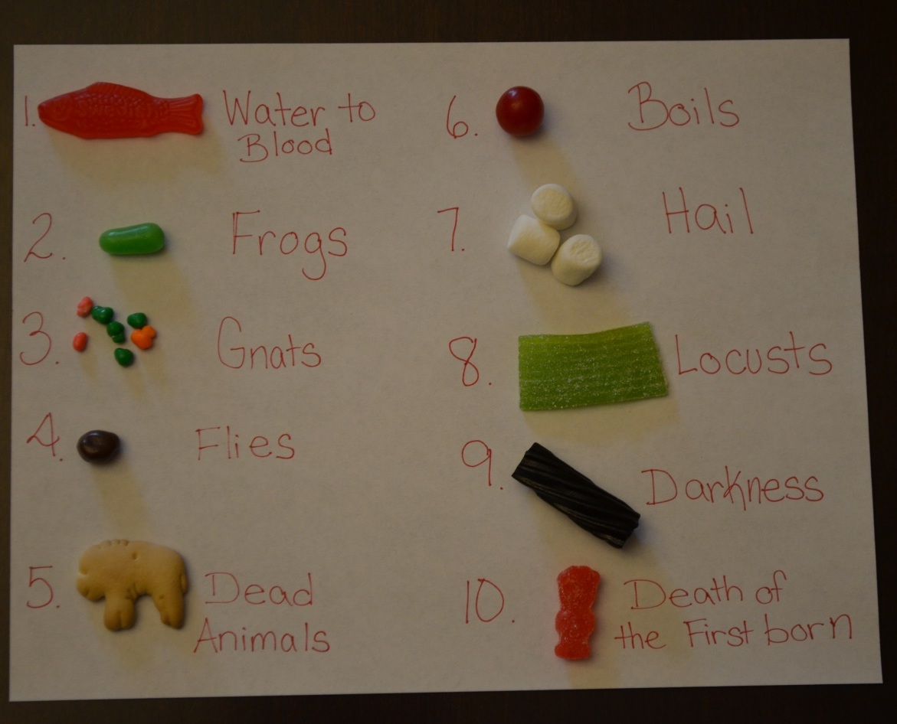

Review Questions
- How long had it been since Moses and Aaron had seen each other?
  - 40 years
- Prior to going to Pharaoh, where did Moses and Aaron go?
  - They went to the Hebrew people and told them that God had sent them to gain their freedom from slavery.
- How did they prove that they had been sent by God?
  - They showed the leaders the signs that God had given them, and the people believed them, and they rejoiced that God had sent someone to help free them from slavery.
- What did Moses and Aaron ask Pharaoh to allow the Hebrews to do?
  - Go into the wilderness and offer special sacrifices to God
- Why did Pharaoh not want the Hebrews to do this?
  - He did not believe in the one, allpowerful God. He worshipped many idols, and he thought he was more powerful than God.
- How did he punish the Hebrew people?
  - He made them work harder than before, and they even had to find their own straw for making bricks.
- What did God tell Moses He was going to do?
  - He was going to send powerful“signs” to prove to both the Egyptians and the Israelites that He was the only God to be worshipped.
- What happened the next time Moses and Aaron went before Pharaoh?
  - Aaron threw down his rod, and it became a snake. Then Pharaoh had his magicians do the same and their rods also became snakes, but Aaron’s snake ate up the other snakes.
- What was the first plague?
  - Turning the water of Egypt into blood
- Did this change Pharaoh’s mind?
  - No. He still would not let the people go.
- What was the second plague?
  - Seven days after turning the water to blood, frogs came up out of the water and covered the land.
- Why were frogs important to the Egyptians?
  - They worshipped a goddess called Heket that they believed took the form of a frog.
- Were the frogs only in a small area?
  - No. They were everywhere. Pharaoh asked Moses and Aaron to get rid of the frogs, and he would let the people go.
- Did he keep his word?
  - No. He changed his mind again and said he would not let the people go.
- What was the third plague?
  - Moses threw some dust into the air, and it became lice, falling on all of the people of Egypt.
- What did Pharaoh’s magicians have to say about this plague?
  - That it was from God, because they could not copy it.
- What was the fourth plague?
  - God sent a swarm of flies that filled the houses of the Egyptians and covered the land. But it did not reach the land of Goshen and the Hebrew people.
- What was the fifth plague?
  - A disease that killed all of the livestock donkeys, horses, cattle, sheep, and camels) of the Egyptians. But none of the Hebrew livestock died.
- What was the sixth plague?
  - Moses took ashes and threw them into the air. When it came down, it caused very painful boils on the Egyptian people. Pharaoh still would not let the people go.
- What was the seventh plague?
  - God brought a hail storm that destroyed all of the crops and plants across the land. Any person or animal that was outside during the storm was killed.
- What was the eighth plague?
  - God sent a great wind that brought locusts that covered the entire country. The locusts ate every plant that the hail had not destroyed.
- What did Pharaoh do?
  - He asked Moses and Aaron to get rid of the locusts, and he would set the people free.
- Did he keep his promise?
  - No. He changed his mind again.
- What was the ninth plague?
  - God sent complete darkness that lasted for three days. But in Goshen, where the Hebrews lived, there were normal times of daylight.
- Why did the Egyptians think the world was coming to an end?
  - They worshipped a Sun god called Re, who they believed was the king of all gods and the “father of mankind,” and they thought that Pharaoh was the son of Re. When the Sun did not appear for three days, they thought their god was dead and the world was coming to an end.

Additional Notes / Activities Performed & Curriculum Feed Back

__________________________________________________________________________________________________________________________________________________________________________________________________________________________________________________________________________________________________________________________________________________________________________________________________________________________________________________________________________________________________________________________________________________________________________________________________________________________________________________________________________________________________________________________________________________________________________________________________________________________________________________________________________________________________________________

