Lesson 4:

First Family/First Murder
SCRIPTURE REFERENCE:
Genesis 2 -4
MEMORY WORK:
Genesis 1:1
Days of creation
PERSONAL APPLICATION:
God planned for families. We can have happy homes if each family member obeys God’s Word and takes care of his/her responsibilities.
LESSON STARTS HERE
INTRODUCTION:
Note”:Sunday and Wedensday will have different lessons this week. Sunday will introduce the family of Adam and Eve, Wednesday will focus on the murder of Abel by Cain.
We are studying “Bible Firsts”. Last week, we studied about the first sin and how important it is to obey God. Can anyone tell me what the first sin was? What happened to Adam and Eve?
Today we are going to talk about the first family. God planned for families, and He tells us in His Word how to have happy families

POINTS TO EMPHASIZE:
- After the first sin, and after God put Adam and Eve out of the Garden, they had many, many children (Genesis 5:4), but we only know the names of three of them: Cain, Abel, and Seth. All their children were born after God put them out of the Garden of Eden.
- God designed the family, just as He did everything else He created. He knew what would be best for all the flowers and animals He created. He also knew what would be best for the people He created. From the very beginning, He planned for one man and one woman to live together for life. God did not create another man to be with Adam, but a special woman. When a man and woman marry, they make promises to God and to each other that they will love and respect each other and live together until one of them dies.
- God knew in the beginning that Adam and Eve would have children and that their children would need a mother and a father to help them grow up. God planned for parents to teach, love, and take care of their children.
- God tells us in His Word how to have happy families. Ephesians 5:22-31 and 6:1-4 tell us that God wants the husband to be the head of the home, and both parents are supposed to treat each other like partners. They should work together to take care of their children and teach their children to obey God. The children in the family have responsibilities, too. What do you think God wants you to do? God expects you to be respectful and obedient to your parents.

RECOMMENDED READING FOR TEACHERS: See the article “Does Genesis 4 Indicate that God Specifically Created Others Besides Adam and Eve?” by Eric Lyons on the Apologetics Press Web site for further study on that subject. See also “Where Did Cain Get His Wife?” and “The Land of Nod” for other relevant background study.
RECOMMENDED ADDITIONAL VISUALS (note disclaimers):

Betty Lukens’ felt pieces
- ABeka Flash-a-Card Series (DISCLAIMER: use the cards, not the lesson book)
- Free Bible Images – Saved on flash drive. Can be presented on classroom tv. Script included in lesson file.
- Church Pictorial Directory – Find Students families. Discuss the different people in our families.
SONGS AND FINGERPLAYS:

“Days of Creation”
Author: Unknown/ Day 6:LeAnn Jones

Day 1, Day 1, God made light when there was none (2xs)
Day 2, Day 2 God made sky and oceans blue (2xs)
Day 3, Day 3, God made land and flowers and trees (2xs)
Day 4, Day 4,Sun, and moon and stars galore (2xs)
Day 5, Day5, God made birds and fish alive (2xs)
Day 6, Day 6, God put animals and man in the mix (2xs)
Day 7, Day7, God rested up in Heaven (2xs)

Ephesians 6:1
Children obey your parents in the Lord for this is right,
In God’s sight, In God’s sight
SUNDAY
LEARNING CENTERS AND ACTIVITIES:
- Bring clothes to represent different family members (mother, father, grandparents, brother, sister, grandparents), and encourage the children to play “dress up,” acting out things that particular family members do (go to work, take care of children in the family, help others, pray, sing, study the Bible, go to worship, etc.)
- Help children make family collages using pictures from magazines, catalogs, and coloring books.
- Make copies of pages titled, “I am Thankful for my Family. Have the children draw the members of their families and, with the teacher’s help, write their names and/or relationships to the children.
- “God’s Plan for a Happy Home” activity: Make a simple line drawing of a house; make two copies for each child. Cut apart the pieces of one of the houses (roof, windows, door, chimney, etc.) as puzzle pieces to fit on the other copy of the house. On each puzzle piece, write something that is part of God’s plan for families (Bible, prayer, love, etc.) Or let the children put stickers on each puzzle piece to represent the same things. Let the children glue the puzzle pieces onto the uncut house which is labeled “God’s Plan for a Happy Home” (provided in activity sheets).

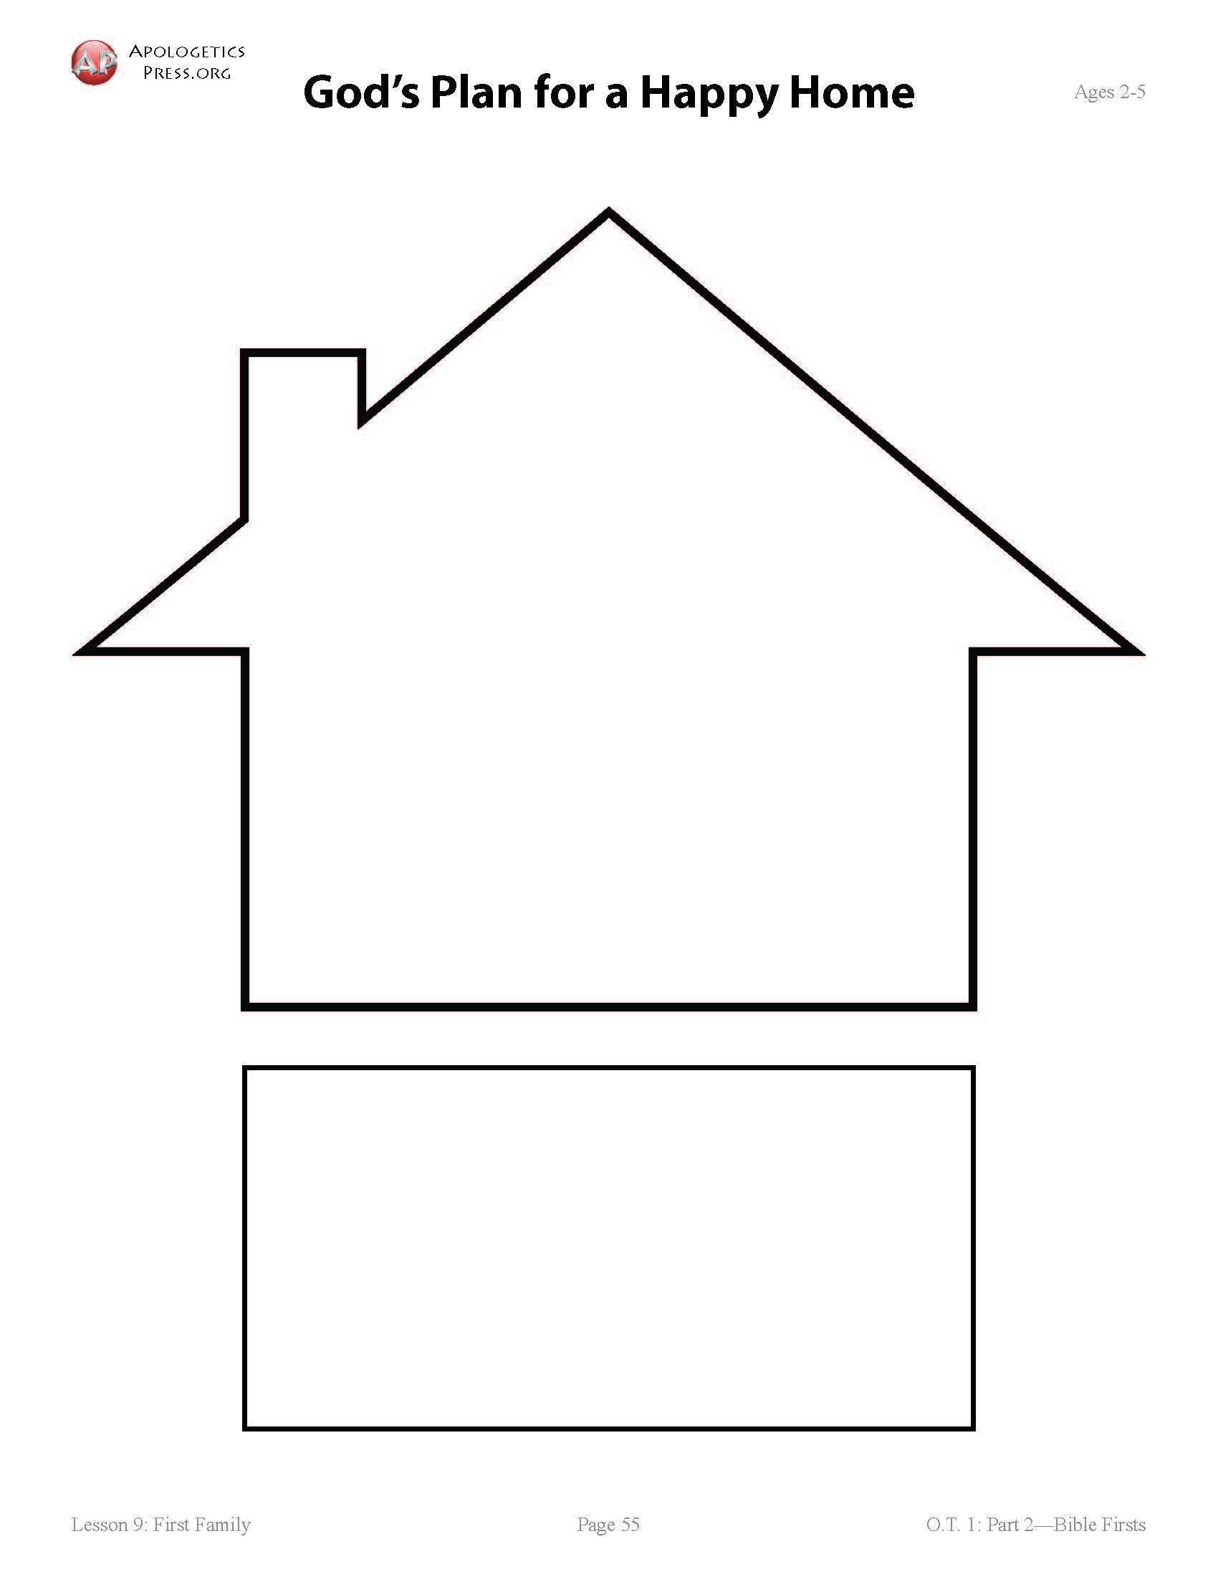

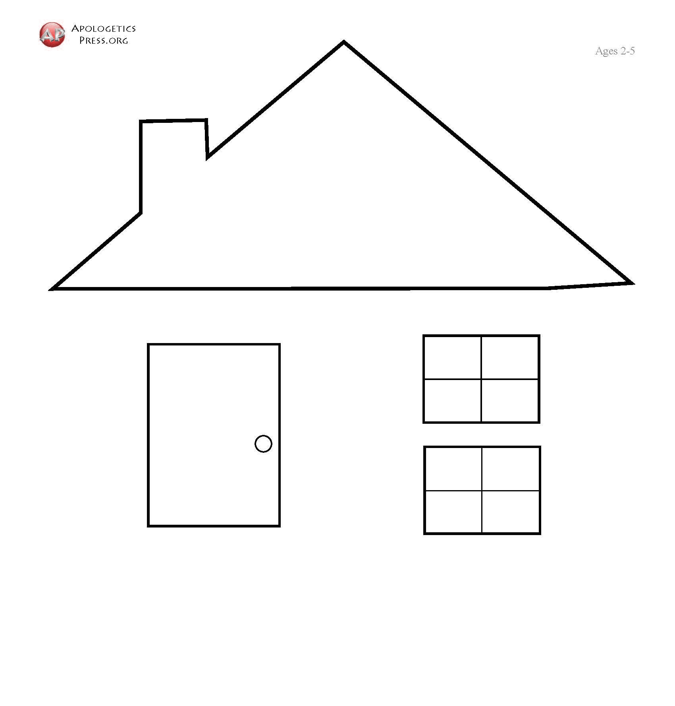

WEDNESDAY NIGHT
PERSONAL APPLICATION:
God is not happy when I am jealous or angry or act hatefully to others. Often, one wrong choice can lead to another wrong choice. So I must always be careful to make the right choices.

LESSON STARTS HERE
INTRODUCTION:
Note:Sunday and Wedensday will have different lessons this week. Sunday will introduce the family of Adam and Eve, Wednesday will focus on the murder of Abel by Cain.
Sunday, you studied about the first family. Who were the members in that family? (Adam and Eve, and their sons Cain, Abel, Seth, as well as other children whose names we do not know) We are thankful to God for giving us families, but sometimes families have problems. Sometimes those problems are caused by wrong choices that lead to more wrong choices. Today, we are going to find out how one brother’s jealousy lead to the first murder. Discuss the meanings of “jealousy” and “murder.”
POINTS TO EMPHASIZE:
- Review Sunday’s lesson. (See Review Questions for example questions.)
- Adam and Eve decided to disobey God because of something they wanted. God gave them the ability to choose between right and wrong. They suffered because they made the wrong choices. (Briefly review their sins and the consequences.)
- After God sent Adam and Eve out of the Garden of Eden, they continued to worship God. An important part of their worship was the animal sacrifices they offered to God.
- Adam and Eve had many sons and daughters. One of their sons, Cain, became a farmer. Another, named Abel, became a “keeper of flocks,” or a shepherd. When it came time for them to make their own sacrifices to God, they each took some of what they had and made an offering to God. Abel’s sacrifice (the firstborn from his flock of sheep) pleased God, but Cain’s (plants from his fields) did not. Why? Because God had told them how He expected them to worship Him and what sacrifices were pleasing to Him.
NOTE: Cain and Abel had to have known what would have been pleasing to God and what was not—even though we are not told what His specific instructions were (cf. Hebrews 11:4; 1 John 3:12). Thousands of years later, when the New Testament was given to man (in the first century), God once again gave instructions about how to worship Him, and just like Cain, many choose to disobey God’s instructions.
RECOMMENDED READING FOR TEACHERS: See “Feelings Follow Facts” by Eric Lyons and “Hermeneutical Principles in the Old Testament” and Surrendering to His Lordship by Dave Miller on the Apologetics Press Web site for further study on Cain’s sacrifice and why it was not pleasing to God.

- Cain was angry with God—and with Abel. He was also jealous of Abel. God talked to Cain about his anger and jealousy, telling him that he must learn to control his thoughts and feelings or his jealousy would lead to more sin.

RECOMMENDED READING FOR TEACHERS: See “The Cost of Anger” by Kyle Butt on the Apologetics Press Web site for a discussion of that subject.
- Sadly, Cain did not control his anger. Instead of trying to learn from Abel’s good choice and from God, Himself, Cain made the awful decision to kill his own brother. Then he tried to hide what he had done by burying Abel’s body in the ground. God knew what Cain had done, but Cain refused to take responsibility for his actions.
RECOMMENDED READING FOR TEACHERS: See “Does God REALLY Know
Everything?” by Eric Lyons on the Apologetics Press Web site for a response to the charge that God is not omniscient since He asked Cain where Abel was.
- Discuss the progression of Cain’s sin: Jealousy Anger Murder Lying No regret or sorrow for wrongdoing.
- Cain was punished severely. From then on, he would struggle in his profession of farming; he and his descendants would be nomads, moving from place to place with no real home. He left his parents and the area where he had been born and went eastward to the land of Nod. But God did put a mark on him so that no one would kill him in revenge as Cain feared might happen.
NOTE: No one knows for sure the exact location of Nod. The land was probably not named “Nod” until after Cain settled there, which would explain its meaning “wandering.”
RECOMMENDED READING FOR TEACHERS: See the following articles on the Apologetics Press Web site for responses to charges against the accuracy of the Bible and against the Creation model:
- “Does Genesis 4 Indicate that God Specifically Created Others Besides Adam and
Eve?”
- “Was Cain or Seth Adam’s Firstborn Son?”
- “Where Did Cain Get His Wife?”
- “Was Cain a ‘Wanderer’ or a ‘Settler’?”

- God is always ready and willing to forgive His children when we do something wrong because He loves us very much. If we are truly sorry for what we have done, ask for forgiveness, and change (repent), God will forgive us. But Cain did not ask for forgiveness; he only complained about his punishment.

LEARNING CENTERS AND ACTIVITIES:
- Build an altar – Use large mega blocks to let students build an altar (big cube). When completed place “fire” on top and discuss the different offerings of Cain and Abel. Use play food and a stuffed lamb.
- Review Game – A simple game like Bible tic-tac-toe or candyland
- Refer to Sunday’s Lesson – Talk to the Sunday morning teacher about any activities not covered during the Sunday morning class for other ideas and activities about the first family.
- Make an edible altar – Build an altar using rectangular cookies or graham crakers. Use pretzel sticks for the wood and red hots or red/orange gummies for the fire.

Review Questions

First Family

Adam and Eve had many sons and daughters, but we only know the names of three. Who are they?

Cain, Abel, and Seth

How did God design a family?

One man and one woman to live together for life, as husband and wife

Who is the head of the family?

The husband or father

First Murder

1. What did Adam and Eve do as their worship to God?

Offer animal sacrifices

What were the professions of Cain and Abel?

Cain was a farmer, and Abel was a shepherd.

When it came time for their sacrifices to God, what were they to take?

What God told them to take

Was God pleased with both of their sacrifices?

No. He was pleased with Abel’s, but not with Cain’s.

How did Cain feel about his rejection?

He was angry, and became jealous of Abel.

What did Cain do to Abel?

He killed his brother.

What did he do when God asked him where Abel was?

He lied and said he did not know where he was.

What was Cain’s punishment for killing Abel?

He would struggle at his profession of farming and would now move from place to place without a real home.

What did God do to Cain so no one would kill him for killing Abel?

He put a mark on him so no one would harm him.

Will God forgive us when we have done something really bad?

Yes. If we are Christians, we can repent and ask for His forgiveness.

Additional Notes / Activities Performed & Curriculum Feed Back

__________________________________________________________________________________________________________________________________________________________________________________________________________________________________________________________________________________________________________________________________________________________________________________________________________________________________________________________________________________________________________________________________________________________________________________________________________________________________________________________________________________________________________________________________________________________________________________________________________________________________________________________________________________________________________________

