Lesson 12:

Sharing: Jacob and Esau
SCRIPTURE REFERENCE:
Genesis 25:19-34
MEMORY WORK:
Genesis 1:1
Days of Creation
PERSONAL APPLICATION:
God wants me to be content and happy with what I have, and to be willing to share what I have with others.
LESSON STARTS HERE
INTRODUCTION:
Isaac married Rebekah and they had twin boys. Does anyone know their names? (Jacob and Esau) Today we are going to learn how badly these two brothers treated each other. Listen as we learn more about them.
POINTS TO EMPHASIZE:
    - Isaac was 40 years old when he married Rebekah. They were married for 20 years and had no children. Isaac prayed to God for children.
    - Rebekah became pregnant, and God spoke to her one day about her baby. First, God told her that there would be not one baby, but two. Second, God told her that the two boys would grow up and their descendants would become two strong nations of people.
HISTORICAL NOTE: “The family name and titles passed through the lineage of the oldest son. The birthright was more than entitlement to the family inheritance; it involved a spiritual position as well. The place of the individual in the covenant status of Israel was part of the birthright and it was this aspect which made the foolishness of Esau so profound” (Zondervan Pictorial Encyclopedia of the Bible).

    - Jacob and Esau were born when Isaac was 60 years old. Because Esau was born first, he was considered the oldest, or first-born son. As the first-born, he would be given twice as much of his father’s goods as Jacob, after his father Isaac died. This custom of giving twice as much to the oldest son was called the birthright.
    - From the beginning, the boys were very different. For one thing, they didn’t look anything alike. Jacob was very smooth-skinned, but Esau had lots of red hair all over his body. As the brothers grew up, they became different in even more ways. Esau became a very skillful hunter and loved to be outdoors. Jacob enjoyed staying closer to home and doing things “around the house,” like cooking. Most parents try very hard not to have “favorites” among their children. But Esau became Isaac’s favorite son, and Jacob became Rebekah’s.
    - One day after Esau had been out hunting, he came home to find that Jacob had fixed a pot of stew (or pottage) that had a red color to it. He was so very hungry that he thought he was starving to death. He asked Jacob for some of the stew.
    - Jacob told Esau he could have some stew if Esau would trade his birthright for it. Esau was so foolish (profane) that he decided his birthright was not as important as having something to eat right that minute. So Esau traded Jacob his birthright for something to eat.
NOTE: Hebrews 12:16 says that Esau was “profane” when he sold his birthright. To be “profane” means to treat something as common/unimportant that should be held in respect. When people take the Lord’s name in vain, they are being “profane” because they should be treating God’s name respectfully. We should always be careful to show respect when it is due!

    - Jacob was selfish because he would not share the stew with is brother. Esau was selfish because he was thinking only of himself. He had no right to sell or trade away his birthright. Both brothers were thinking only of themselves.
    - God is not happy when we are selfish. He wants us to share what we have with others. But He doesn’t want us to share, expecting that person to do something for us or give something to us in return. God gives us what we have and wants us to make the right decisions about using those blessings.

RECOMMENDED ADDITIONAL VISUALS (note disclaimers):

Betty Lukens’ felt pieces
- ABeka Flash-a-Card Series (DISCLAIMER: use the cards, not the lesson book)
- Free Bible Images – Saved on flash drive. Can be presented on classroom tv. Script included in lesson file.
- See AP’s pinterest page for ideas. www.pinterest.com/apcurriculum
- Act out the story with props – tent, pot with play veggies in it, bowls, bible clothes
SONGS AND FINGERPLAYS:
“3 Wandering Jews”

Once there were 3 wandering Jews (repeat)
Wandering, wandering, Jew-Jew-Jews (repeat)
Once there were 3 wandering Jews.

The first one’s name was Abraham (repeat)
Abra-Abra-ham-ham-ham (repeat)
The first one’s name was Abraham

The second one’s name was Isaac (repeat)
I-I-saac-saac-saac, (repeat)
The second one’s name was Isaac

The third one’s name was Jacob(repeat)
Ja-Ja-cob-cob-cob, (repeat)
The third one’s name was Jacob.

The all went down to Canaan land, (repeat)
Canaan, Canaan, land, land, land, (repeat)
They all went down to Canaan land.

SUNDAY
LEARNING CENTERS AND ACTIVITIES:
- Act out the story.
- Draw the Story – Give students blank copy paper and let them draw Jacob and Esau. Jacob should look like a “smooth skinned” man and could be drawn with crops since he was a farmer. Esau should be hairy and could be carrying a bow and arrow. Drawing the characteristics should help the students remember the differences in the two brothers.
- Jacob or Esau? Game - Laminate a copy of the Jacob and Esau Figures and place magnets on the back. Put Jacob on one side of a magnetic dry erase board and Esau on the other. Have characteristics of each brother written on strips of cardstock with magnets on the back. On a student’s turn, read the characteristic and let the student place it under the correct brother. This is a good short review game to keep out for a few weeks.

WEDNESDAY NIGHT
POINTS TO EMPHASIZE:
- Review Sunday’s lesson. (See Review Questions for example questions.)
- Discuss practical opportunities for kids of all ages to share and not be selfish. Show them pictures of children who do not have all the blessings they have and who need help.
LEARNING CENTERS AND ACTIVITIES:
- Stew Review: Write review questions on the back of die cut or printed out vegetables and place in a large bowl (a Halloween cauldron would work well). Divide the class into two teams. Give each team a small bowl. Alternate turns asking each team a review question. If the team answers correctly they get a vegetable for their bowl. The team with the most vegetables wins.
- Eat Soup – Bring a thermos of soup and let the students sample it. Talk about how yummy the soup is, but is it worth selling the birthright for?

Esau and Jacob Figures

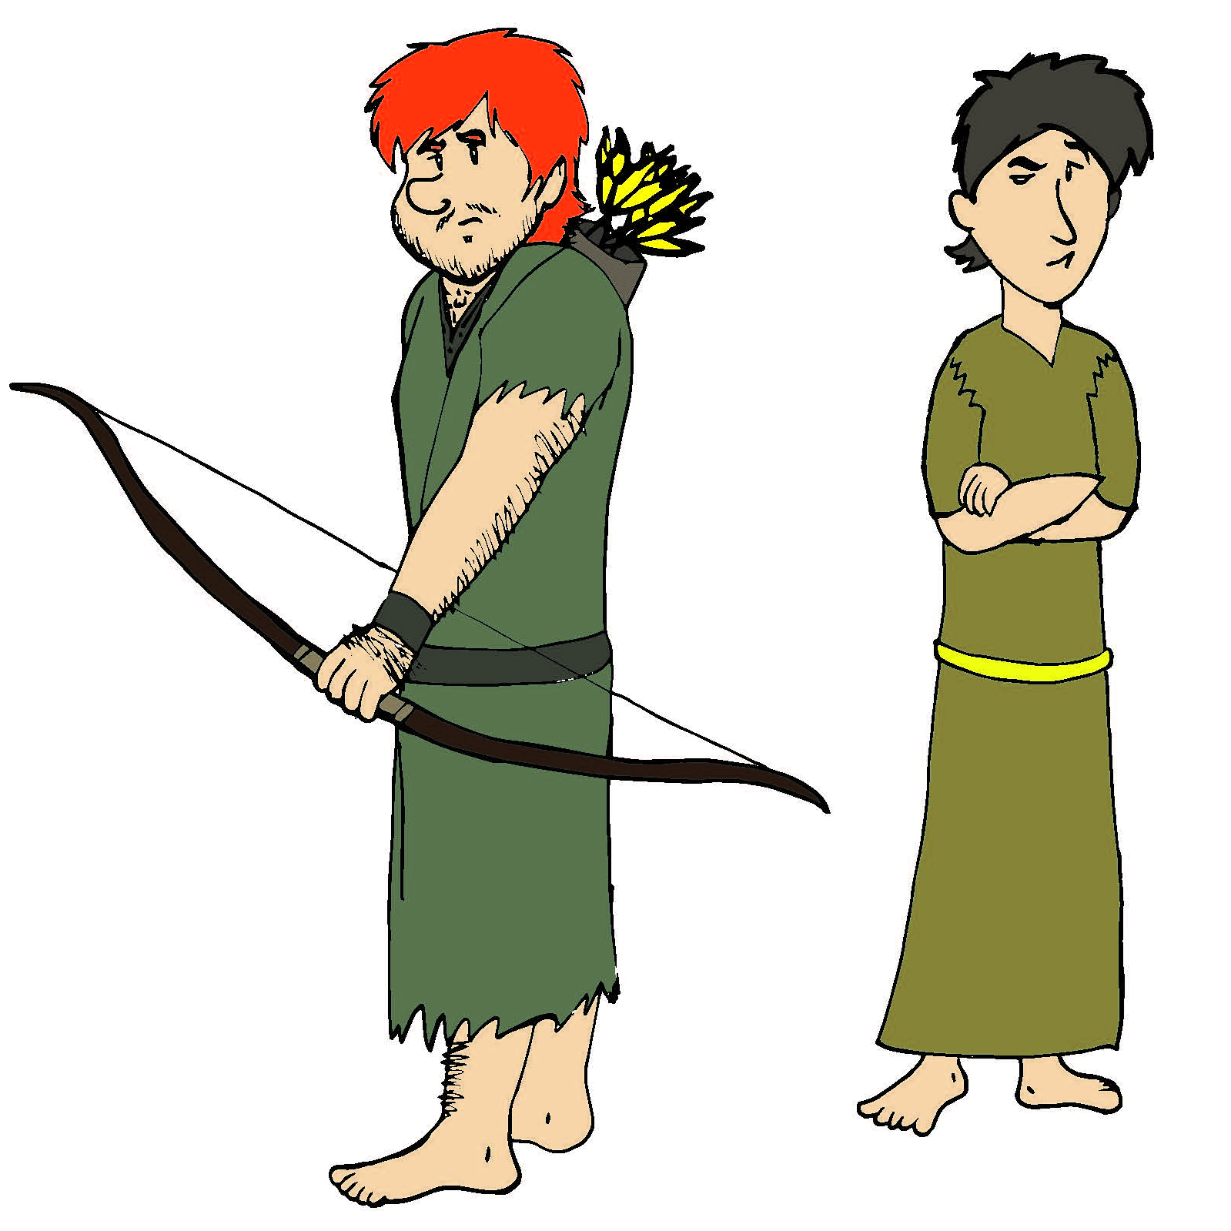

Review Questions

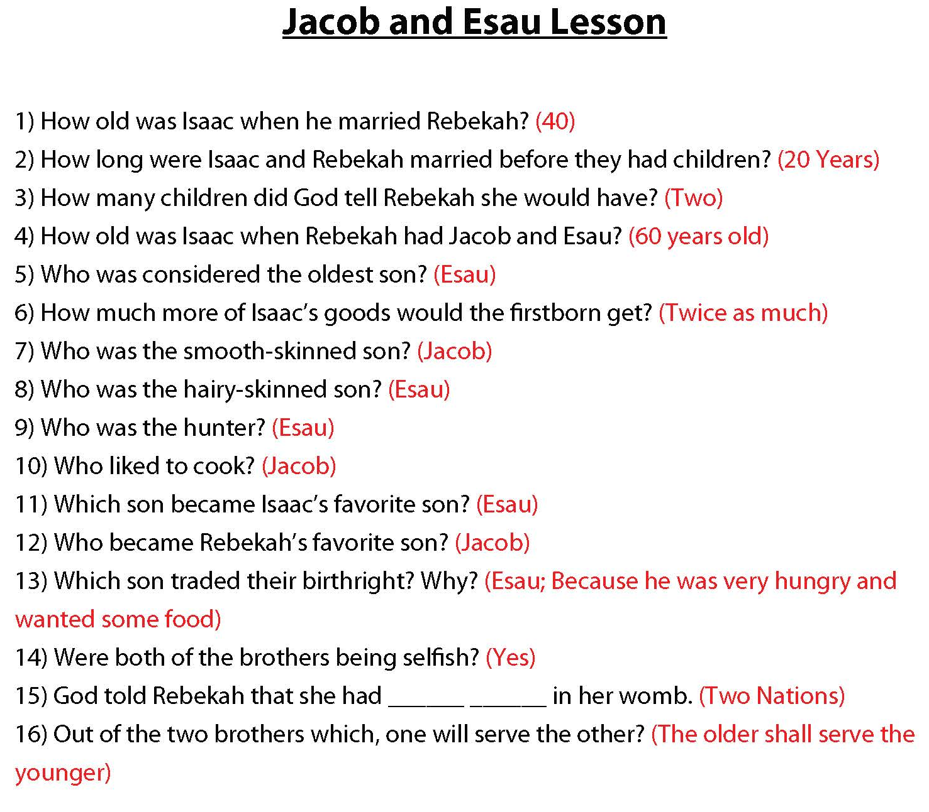

Additional Notes / Activities Performed & Curriculum Feed Back

__________________________________________________________________________________________________________________________________________________________________________________________________________________________________________________________________________________________________________________________________________________________________________________________________________________________________________________________________________________________________________________________________________________________________________________________________________________________________________________________________________________________________________________________________________________________________________________________________________________________________________________________________________________________________________________

